1513_Final Selecting Data from our Database tables.
NOTE: There is a script attached to this assignment, you need to
USE APEX SQL Workshop→ SCRIPTS→UPLOAD→ RUN then check object browser for tables starting with FINAL_

Turn in Screen print of SQL statement and RESULTS & upload to blackboard.

- Select all columns and only records that Major is equal to 10 or 13 or 15 USE an IN operator Sort by Major ID in descending order. (MAJORS)
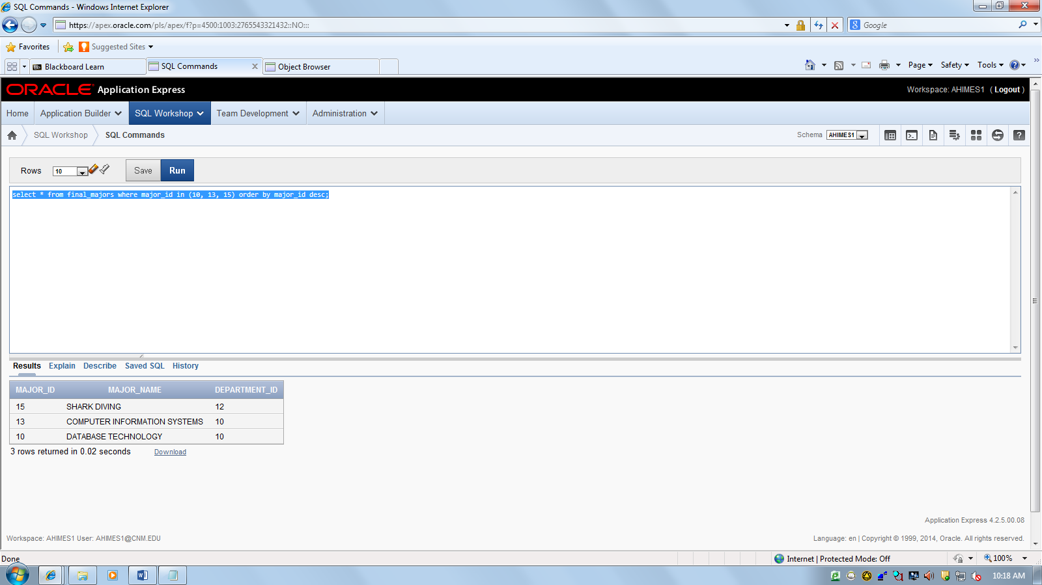
.
- Select all columns from BUILDINGS that are on Main Campus. Sort by Building Name.

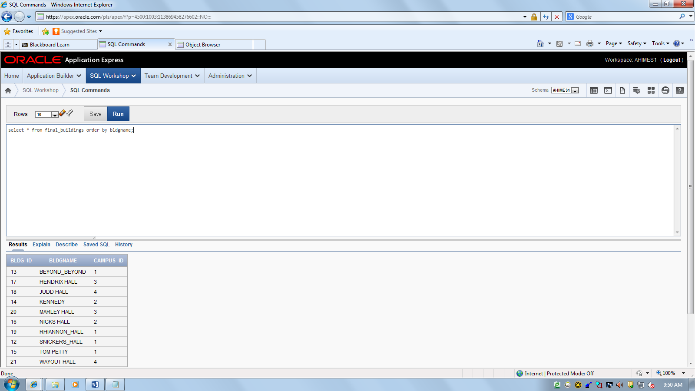

- Select employees who have a:
Job_id of IT_PROG OR hire_date greater than April 1, 2004
NOTE: dates in APEX must be in mm/dd/yy format '01/01/13'
NOTE: dates in SQLDEV must be in the oracle date format '01-JAN-13'

Display Employee_id, last_name, job_id, hire_date. Sort by Hiredate desc order.

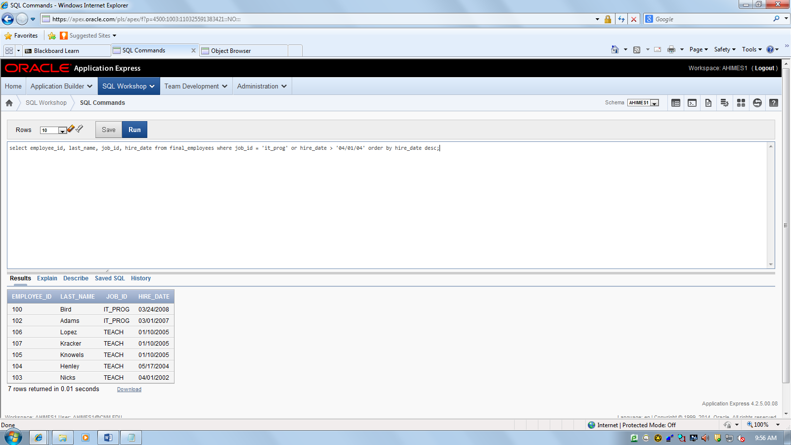

- Find the students living in City = Belen
Display the student first name, last name, city, major Sort the data by last_name

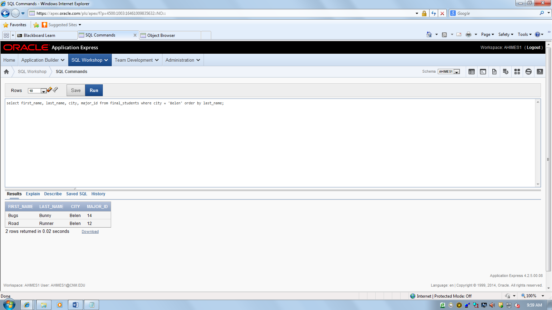

- Select all columns(*) from Courses that have the word SQL in them. USE the LIKE statement. Sort by Course_Name

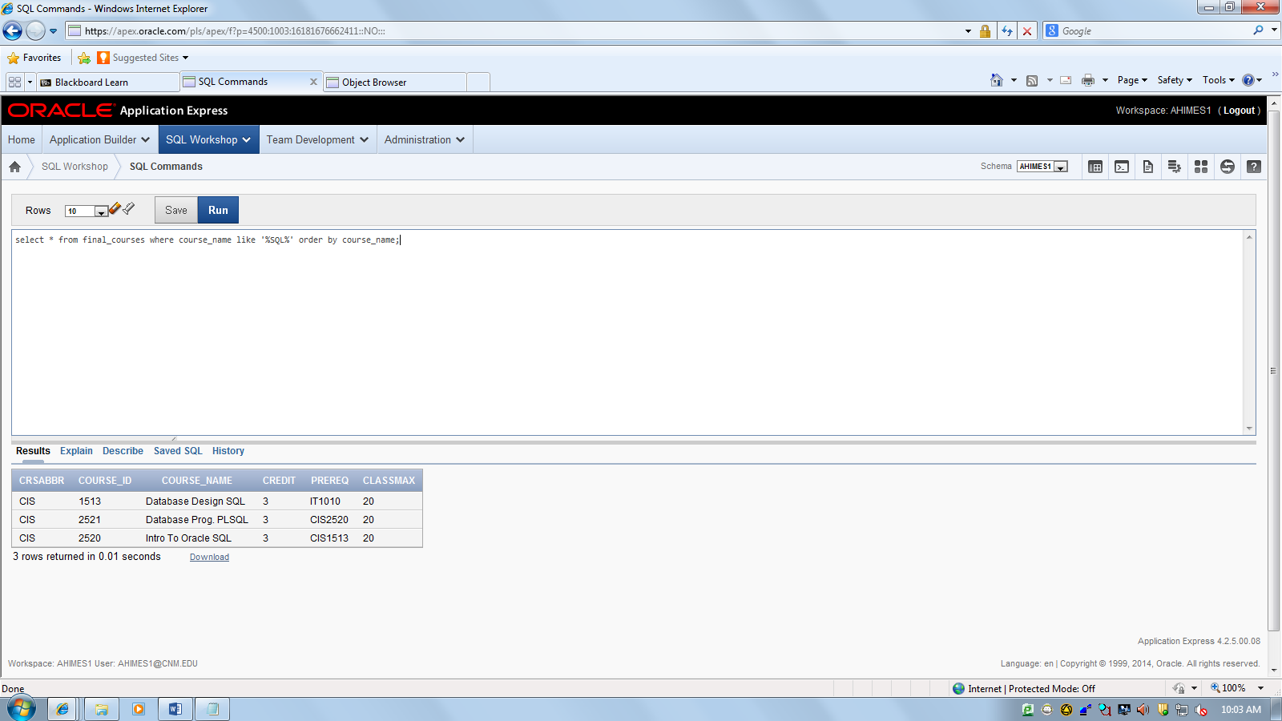

- Select all columns from enrollment where Student ID is 11111 or 33333. Sort by Student ID and CRN (both in descending order)
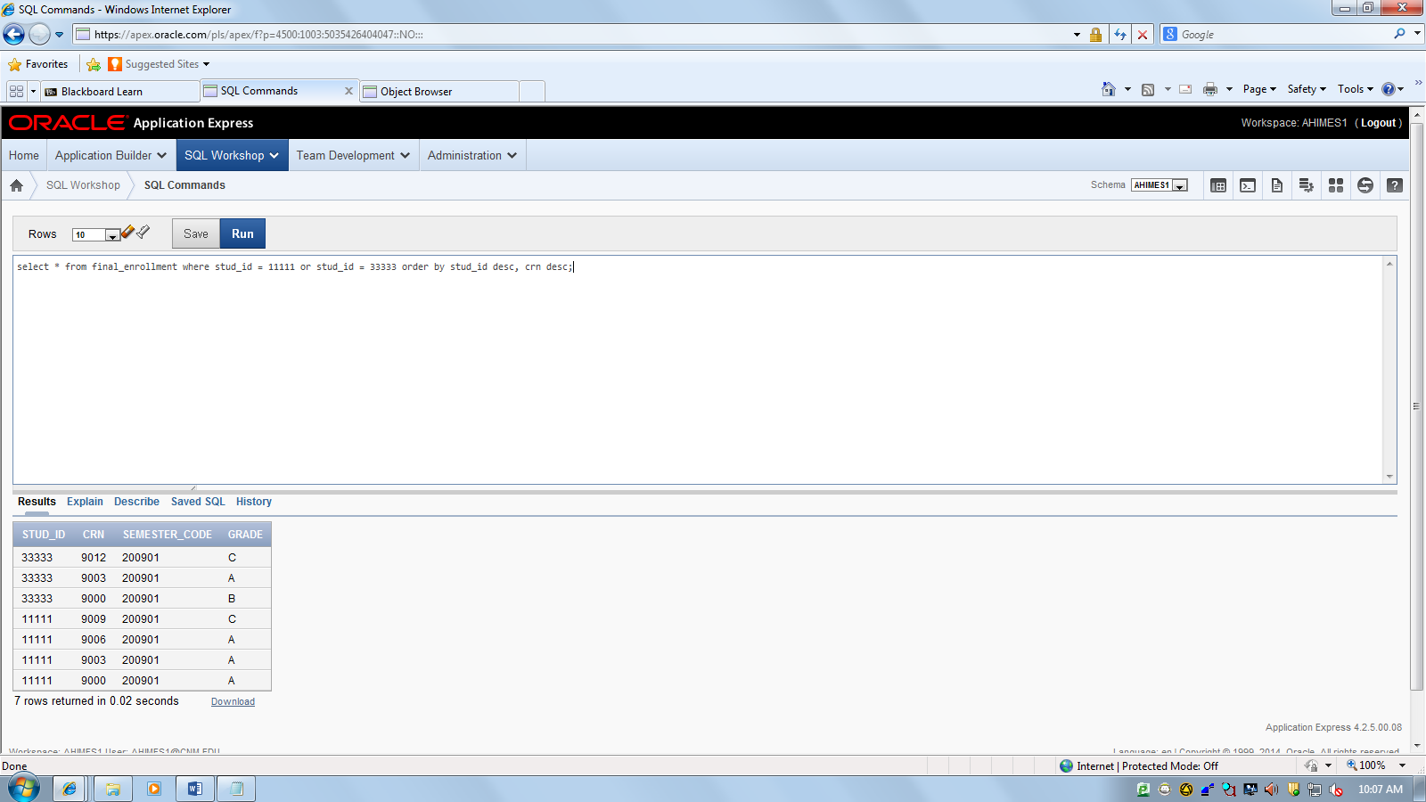

- Find all students who received a: B for their Final Grade and were enrolled in CRN 9000. Sort by CRN in descending order.(Enroll table Show all col

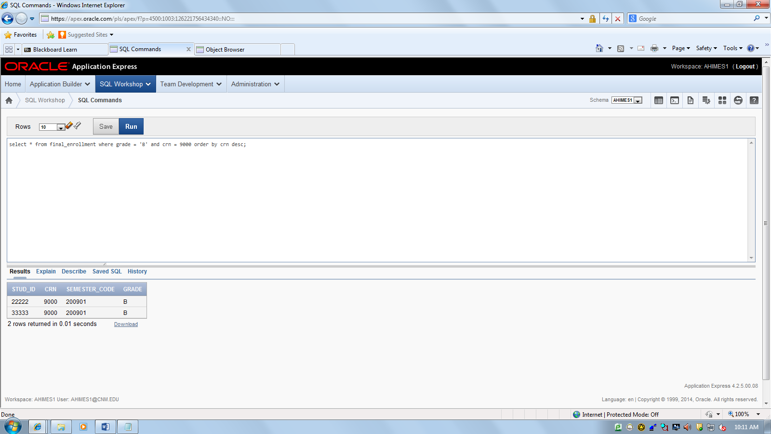

- Select all columns from ROOMS and show only records that have computers in them. Sort by Building and Room in descending order.
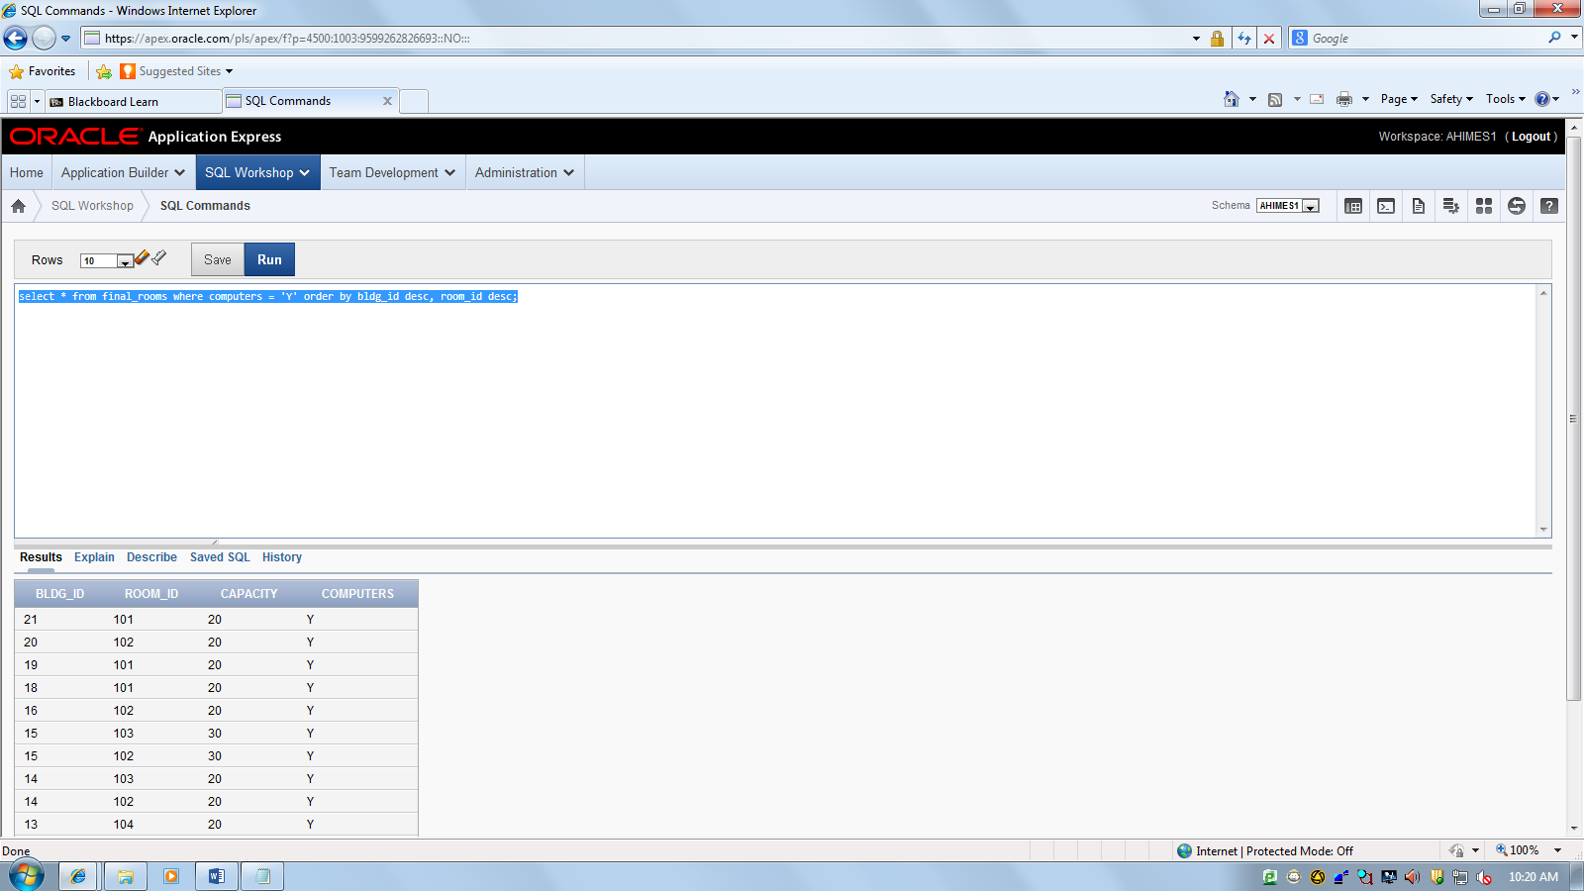

- Display the following fields: CRNNO,CRSABBR,CAMPUS (Classes) and only find CRNs that are between 9005 and 9010 Use the BETWEEN clause. Sort by CRN in descending order.

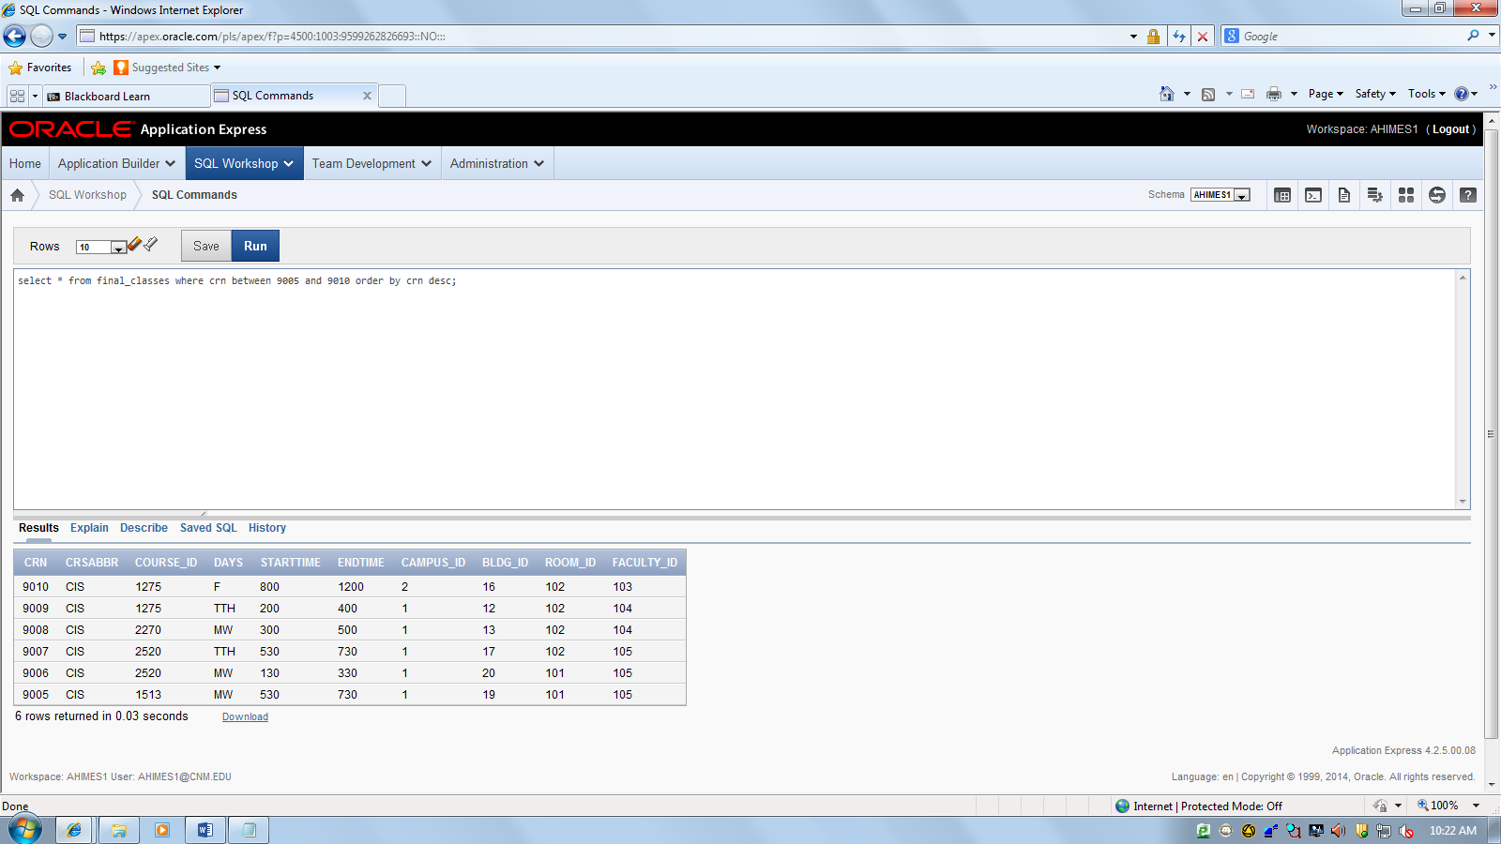

10. Display the Student Number, City, concatenated field (Put together first and last name with a space in between call the column Student_Name)
(Use students table) Sort by City, student ID (both in descending order)

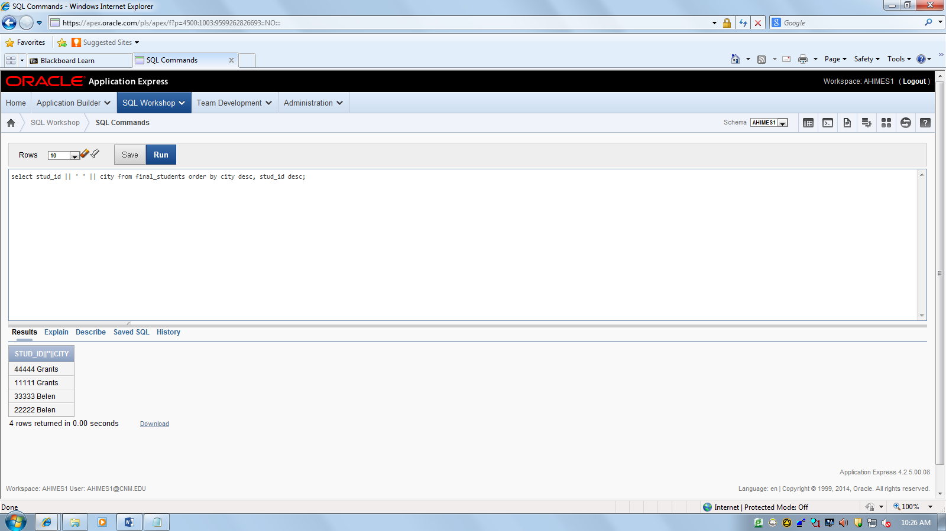

11. Display all columns from the CLASSES table and only show
CRN =9000 or 9003 (USE IN statement)

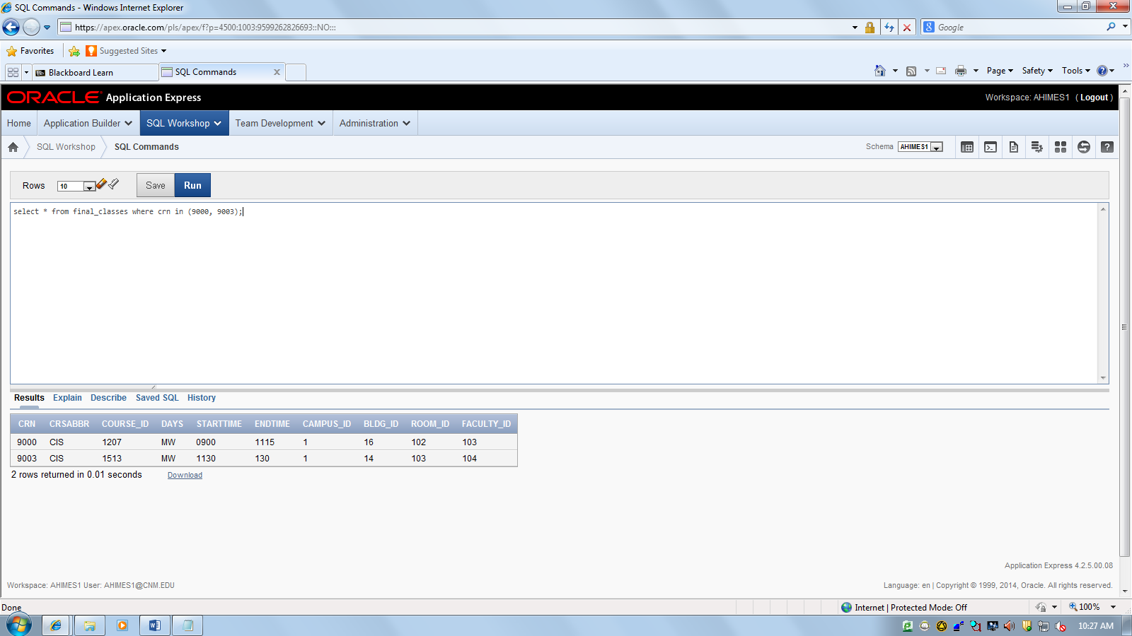

12. Display all columns from the BUILDINGS table and only show Building ID’s between 12 and 15 USE a BETWEEN statement.

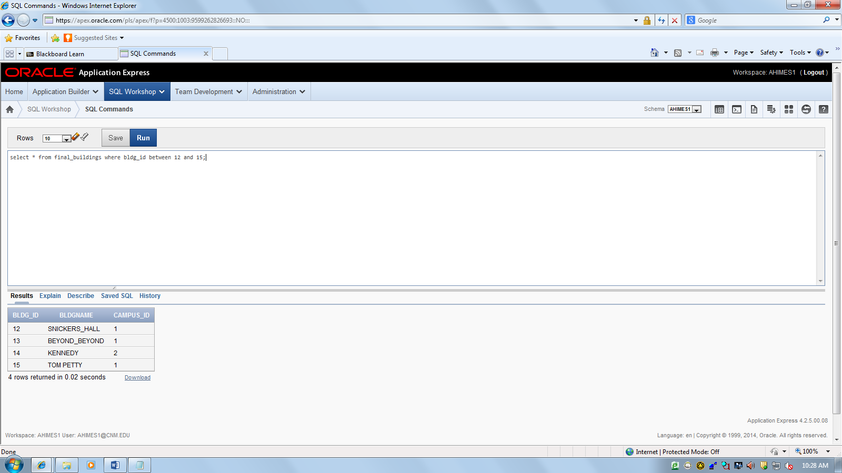

EXTRA CREDIT:
Example: Join tables using the FK and PK
Select * from employees, departments --2 tables
Where employees.department_id = departments_id -- 1 join

Select * from employees, departments, jobs ----3 tables need 2 joins
Where employees.department_id = departments_id
AND employees.job_id = jobs.job_id

- JOIN together the STUDENT and MAJORS table, Show all columns and compare the FK and PK columns to make sure they are the same.
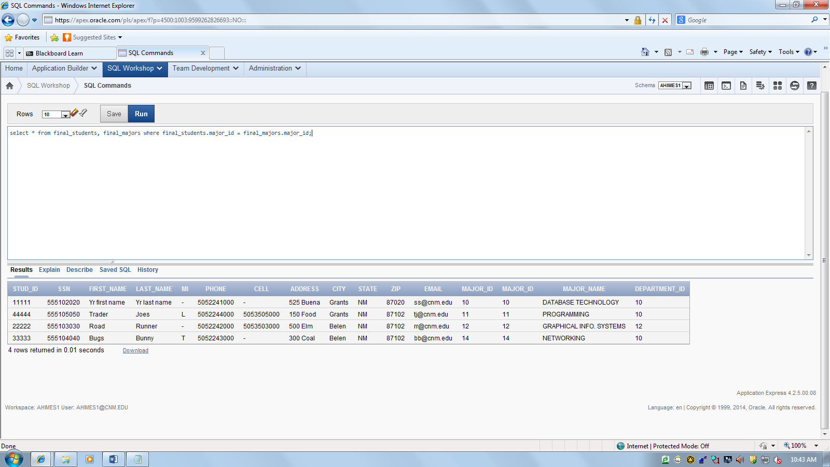

- JOIN together the ENROLLMENT and CLASSES table, Show all columns.
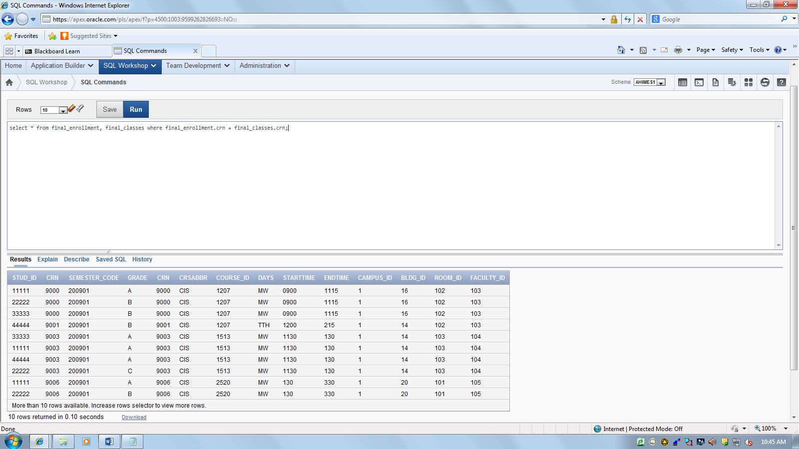

3. JOIN together the STUDENT, ENROLLMENT, CLASSES tables
Show all columns.

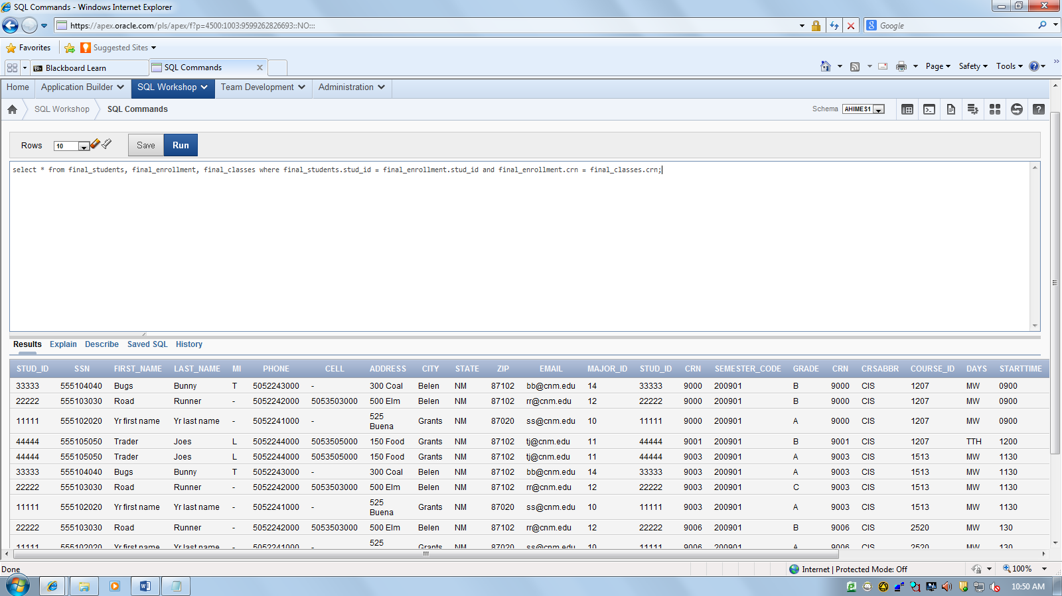

- Revise question 13 to only show CRN =9000 or 9003 (USE IN statement)

(revising question 3)
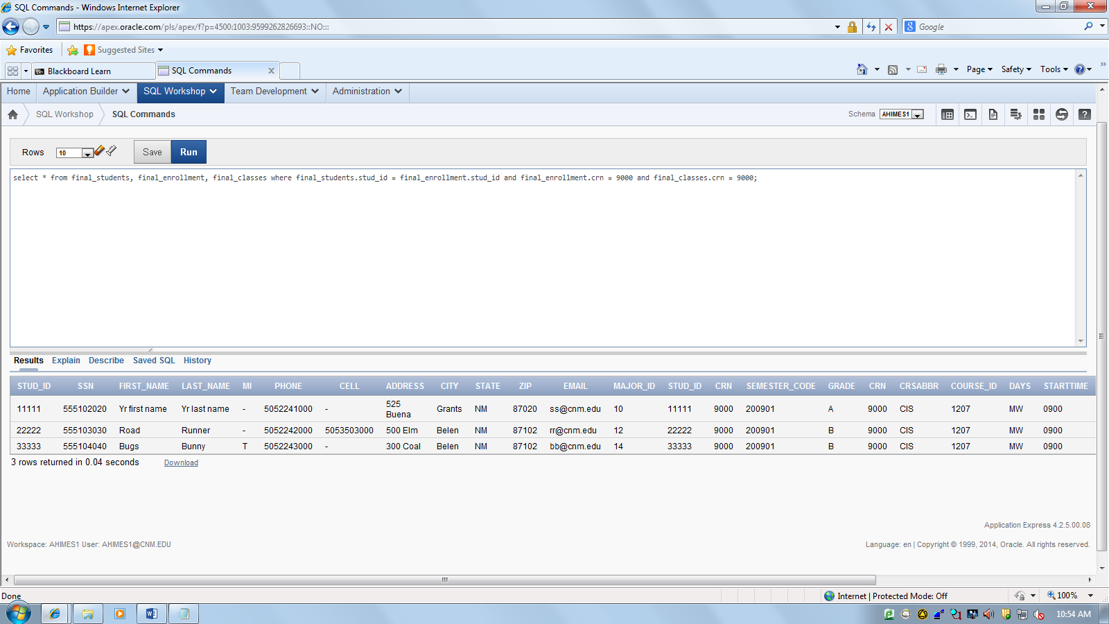

5. JOIN together BUILDINGS and ROOMS, show all columns. Only show
Building ID’s between 12 and 15 USE a BETWEEN statement.

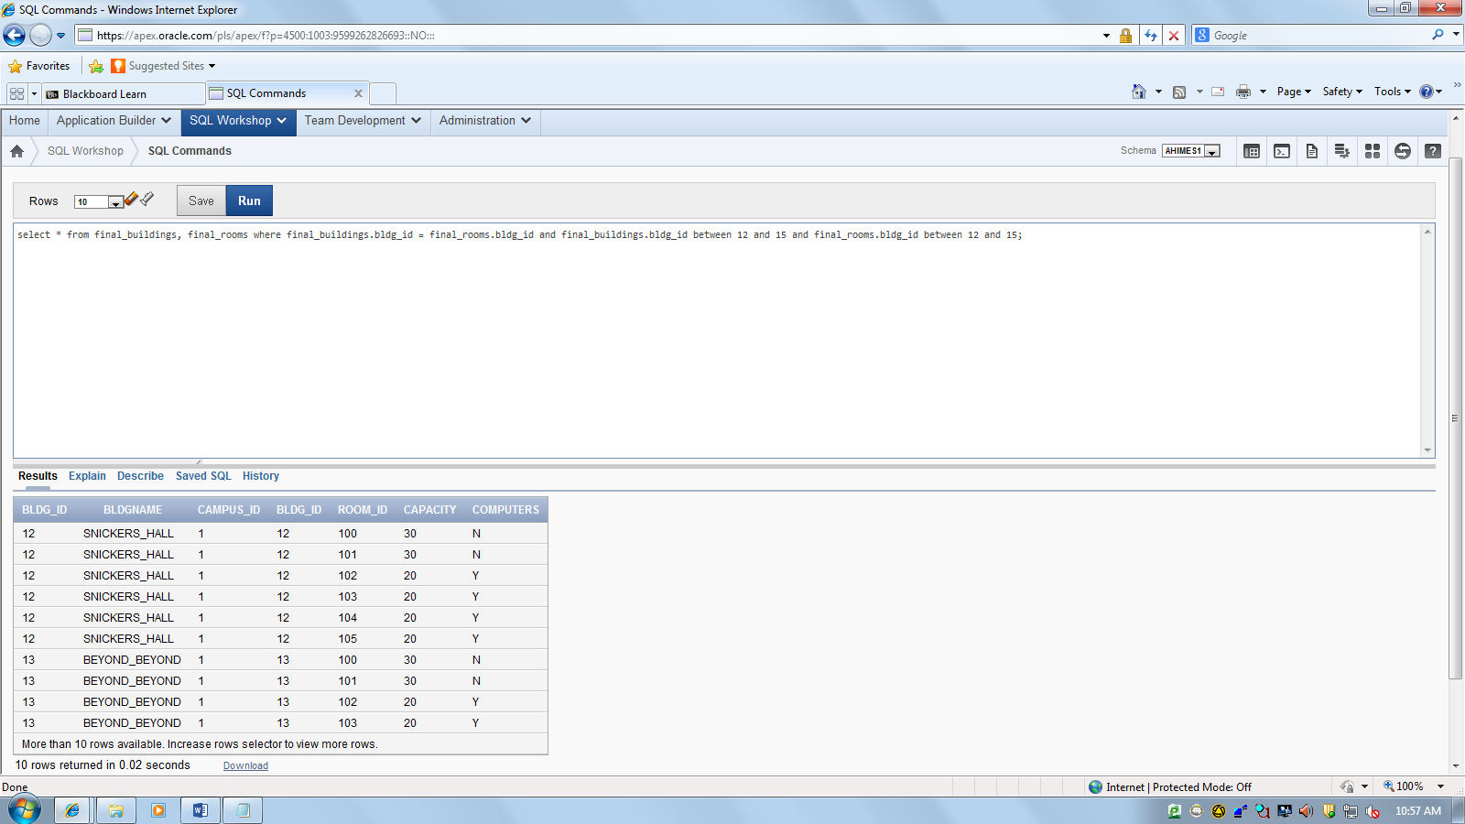

That’s all my SQL folks, Hope you had a great semester, Have a great break.

You too, thanks!! -Alan

